Assignment -4

Docker and Kubernetes

|  |  |
| --- | --- |
| Assignment Date | 21 October 2022 |
| Team ID | PNT2022TMID22126 |
| Project Name | Smart Fashion Recommender |
| Maximum Marks | 2 Marks |

1. Pull an image from docker hub and run it in docker Playground

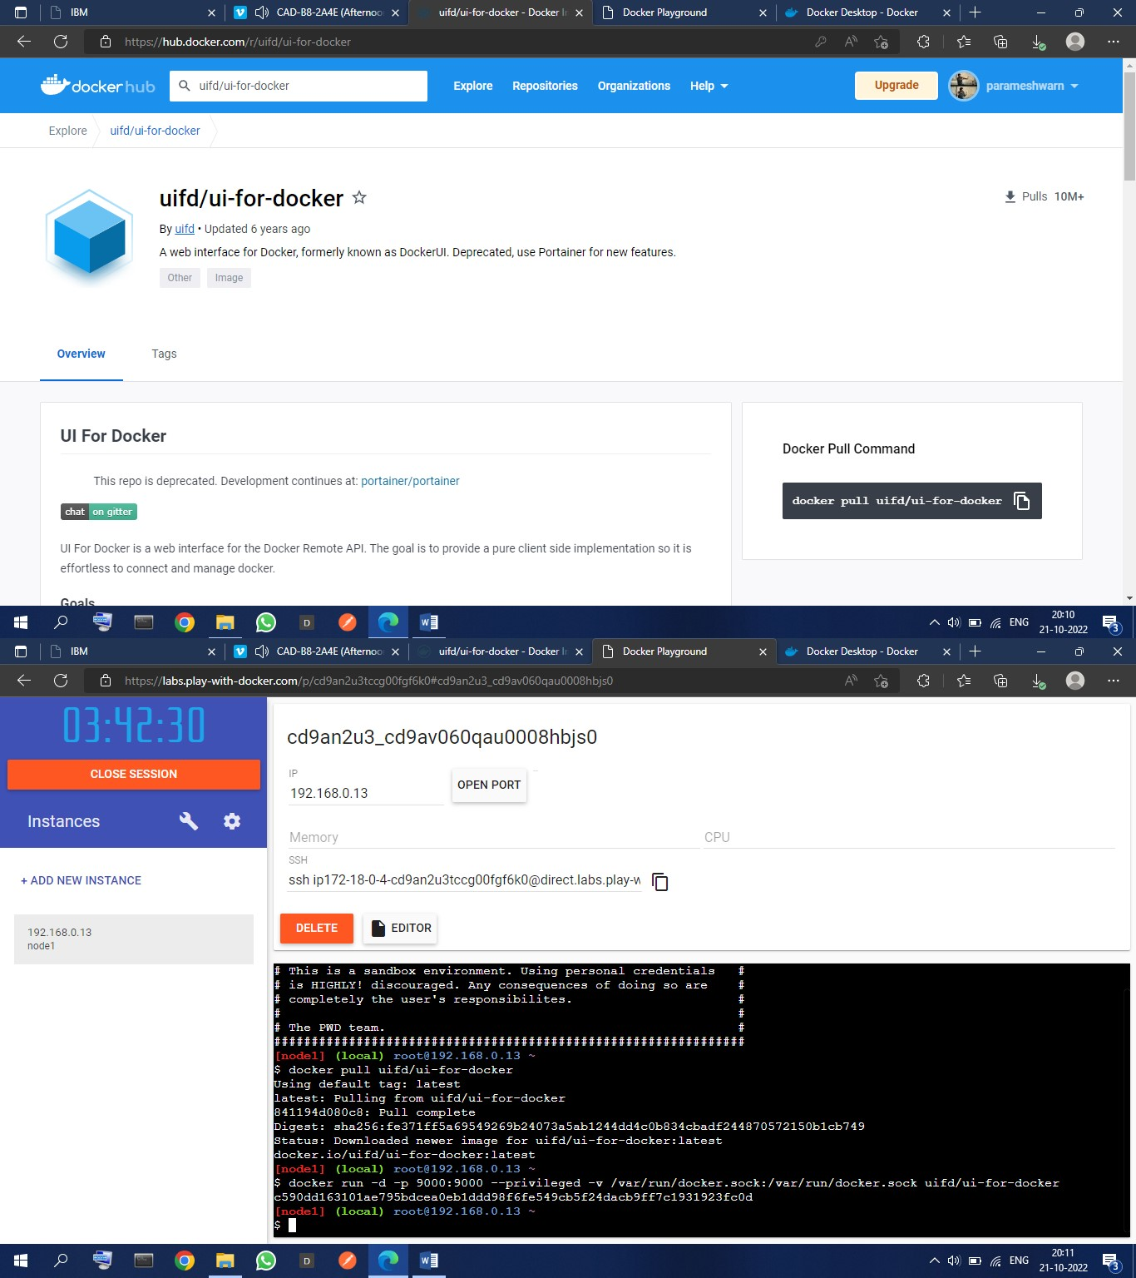

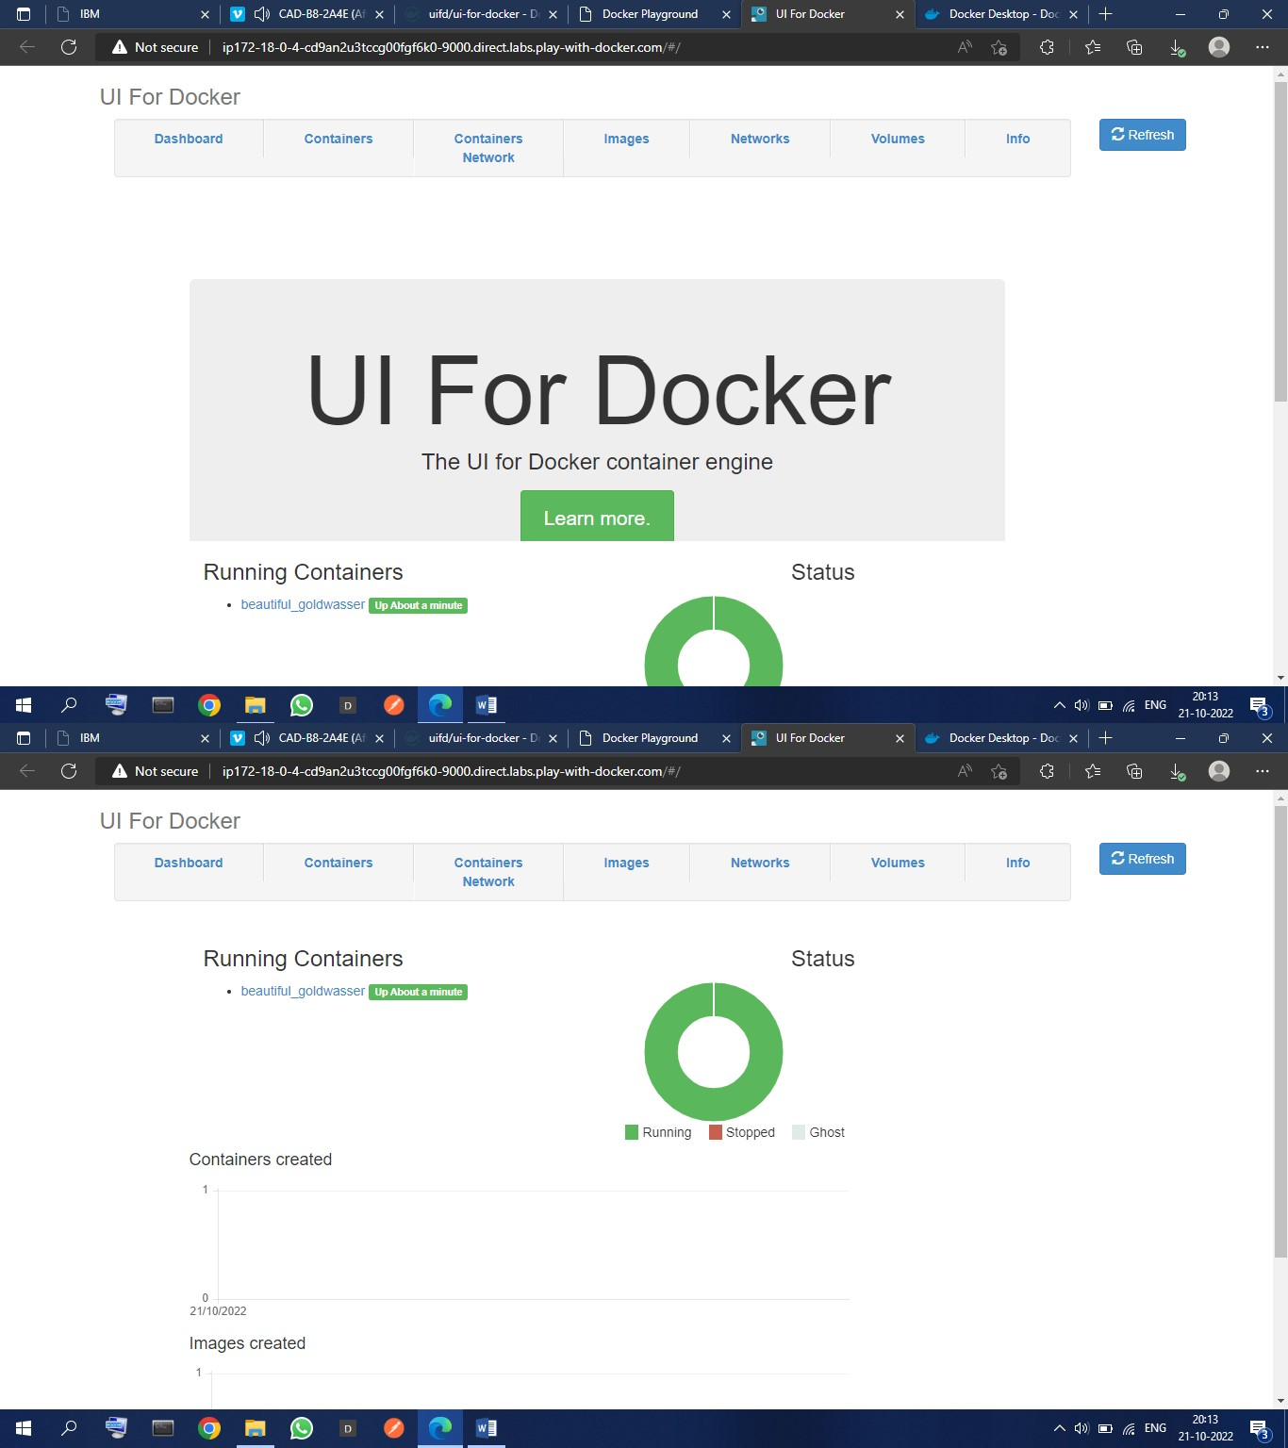

1. Create a docker file for the job portal application and deploy it in Docker desktop application

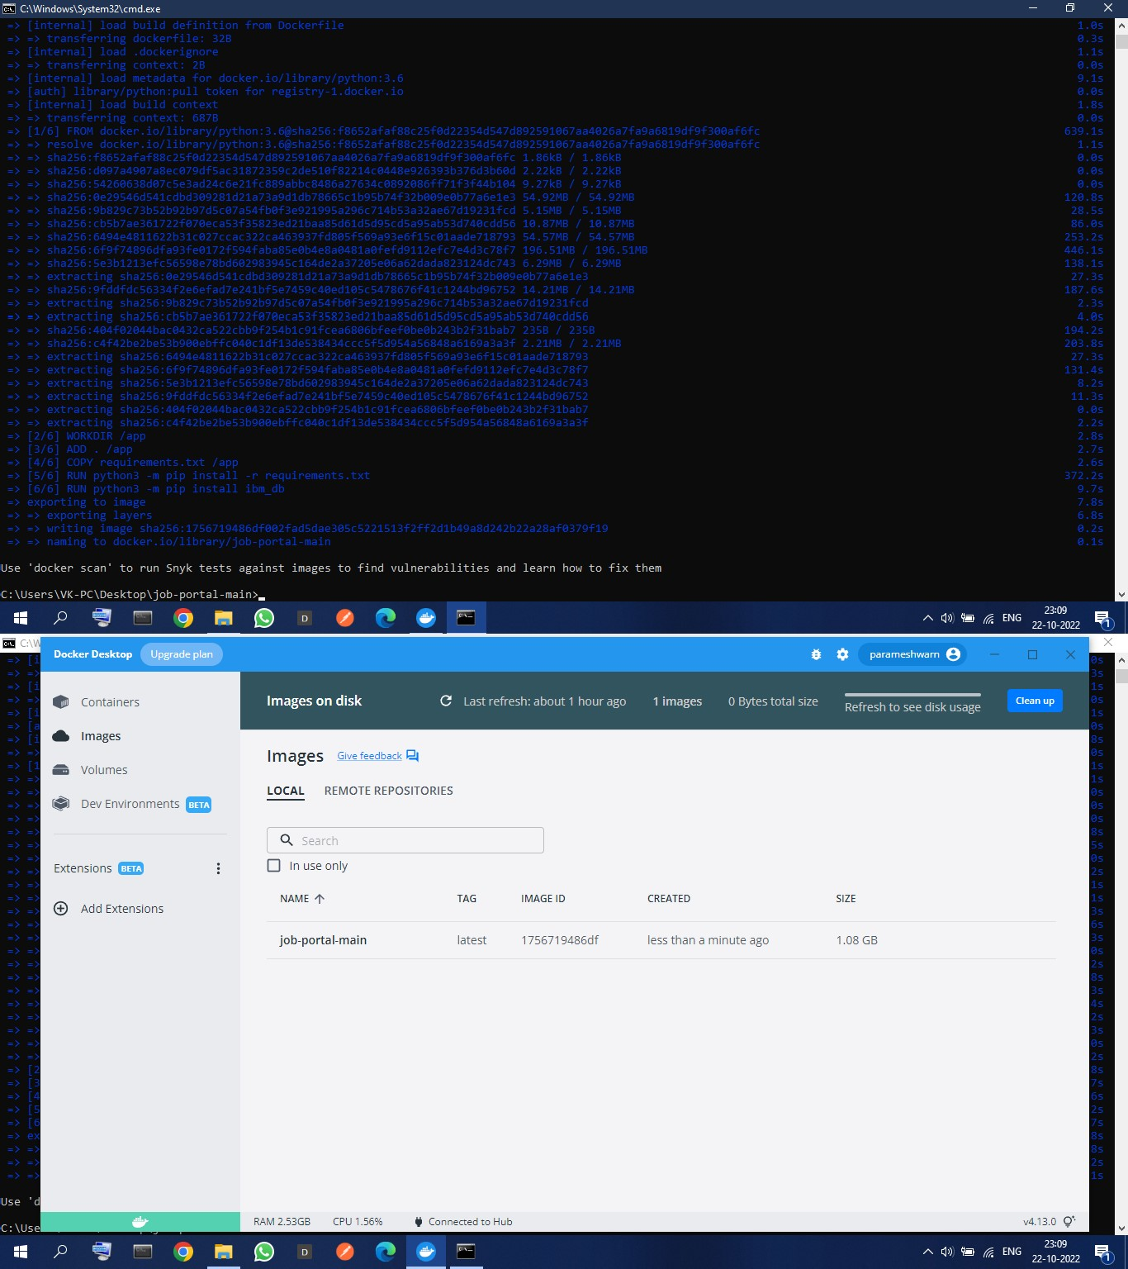

1. Create a IBM container registry and deploy helloword app